ISQA4900
Activity 2
Yizhuang Chen

Take one or more screen shots of your website and add it to the word document.


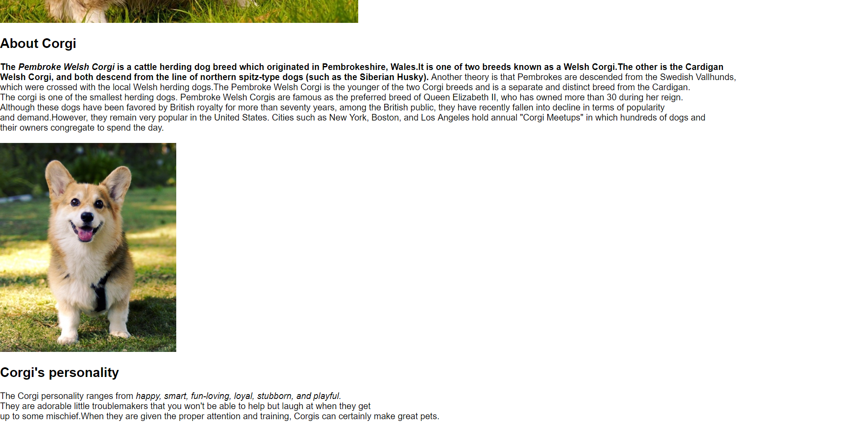

Include answers to the following questions in your document file (use your own words):
- What is the value of having a CSS file for each HTML page? Why not simply embed the CSS in each web page?

Because DRY (Don't repeat yourself) is an important programming principle, the separation of structure and style is beneficial to maintenance and collaboration. For example, if one CSS can decorate 100 HTML and write separately, you only need to write one CSS; and if you write all into HTML, you need to write 100 CSS. It takes up a lot of space and users will be slow to open web pages.

- There are many cloud-based shared document tools such as DropBox, Box, Microsoft OneDrive and GoogleDrive. What is an advantage of using a tool like Git (GitHub Desktop) and GitHub over simply using other cloud-based shared document tools to manage code?
Compare to other cloud based:
1.GitHub can browse push pictures directly on the website
2.Github can directly comment and reply on the number of lines of code
3. GitHub Markdown supports very good github issues, and the wiki pages are all well designed, making it easy for non-Engineer users
4.GitHub is constantly modifying and improving the interface, and it is often changed
5.There are many projects on github, there are many things that can be learned, and there are many excellent projects, so it has become the programmer's Facebook.
6. there are a lot of open source projects, which are suitable for finding the code you need.

